Introduction
For the calculation of PiN, severity scores are a perquisite and must be produced at disaggregated geographic and/or population group levels – for example, for the Internally Displaced Persons (IDP) population specifically and/or for each Admin 1 or 2 geographic area.
This note provide support on developing severity scales for Protection cluster including AoRs and aim to support field colleagues with the methodology of producing Severity scales before the PiN calculation.
Protection actors use the severity scale as a measuring tool to score and identify the geographical areas most affected by the crisis. The severity scale proposed by the Protection Cluster follow the same five level severity thresholds as suggested by JIAF (for the intersectoral severity scale). Protection cluster / AoRs PiN and severity figures should always be estimated as per the validated and established methodology listed below.

What is an Overarching Protection Severity Scale ?
It is the overall severity score for a given area for the whole Protection Cluster - including AoRs, based on indicators score of both Protection and AoRs. This overarching Protection Severity score features in the Protection Chapter of the HNO.

What is an AoR specific Protection Severity Scale ?
AoR Protection Severity Scale score is meant for a specific AoR which is based on their indicators. AoRs can make use of their selected indicators for the overarching Severity or use additional or entirely different indicators. It includes AoR specific indicators and is the scale reflected in the AoR chapters of the HNO. Each of the active AoRs in the country of operations should have a specific scale.

Source of Protection indicators

JIAF Protection and AoRs indicators
You can find the consolidated lists of Protection and AoRs indicators, together with the proposed severity thresholds at household level, in the JIAF 1.1 guidance (see page 6). Or alternately click here to directly access the indicator reference table.

JIAF Non-Humanitarian Conditions Pillars indicators
JIAF Non-Humanitarian Conditions Pillars indicators can also be used for the Protection Severity Scale. It is a list of area-based indicators for the context, shocks and impact pillars of the JIAF and categorized by Protection, Areas of Responsibility, other sectors (i.e. Food Security, Health etc.). If you want to use them for your severity scale, you can follow the same logic of the JIAF Protection Critical indicator for Severity 5 (50% higher of the total).
You can find the JIAF Non-Humanitarian Conditions Pillars in Annex 3 of the JIAF 1.1 guidance (see page 49).

JIAF indicators aligned with the PAF
To make the selection of indicators and the linkages between the JIAF and PAF easier for country operations, we have aligned both lists of JIAF indicators with the PAF pillars and sub-pillars. Click here to download the indicators list.

Methodology
It is advisable to create an ‘Analysis Team’ with participation of Protection and AoRs Coordinators and IMOs. The role of the Cluster/AoR Coordinators is to select the set of indicators and confirm or agree on the thresholds. The role of the Information Management Officers is to consolidate the data and apply a scoring to each of the geographical units of analysis. The inclusion of local and national actors in the ‘Analysis Team’ is highly recommended not only for accountability purpose but also to accurately portray the sectoral needs of the affected population.

Selection of indicators
The severity scale classification is conducted at country level, using the data collected and analyzed for the HNO. The first step for the ‘Analysis Team’ is to select sectoral (and cross-sectoral) indicators for inclusion in the Protection cluster and AoRs severity model to gather evidence of severity.
The above-mentioned sources for Protection and AoRs indicators lists should always be consulted as a first step. To further refine sectoral analysis as needed, additional indicators, including indicators from other sectors which are relevant for protection analysis in your country can be added to the severity model.
The ‘Analysis Team’ define sources for the selected indicators. The data to measure these indicators can be collected through a range of sources, including multi-sector needs assessments, sector-specific or thematic surveys, cluster information management systems, Prevalence indicators, Area indicators, Protection Monitoring, MRM, government statistics agencies, DTM, Protection Monitoring mechanisms in country, among others.
For the identification of affected population, the Protection Cluster uses the categories defined in the 2016 Humanitarian profile Support Guidance.
For specific indicators for which the team on ground is unable to find the severity scale thresholds in the lists mentioned in the previous section, those can be determined according to the available baseline data, context analysis and expert judgement. Some important factors to consider while developing the severity scale could be determined by the:
- specific humanitarian needs of the population groups;
- existing and projected assistance targeted for the affected population group; and
- the magnitude of humanitarian impact on the affected population group.
Additionally, please see section ‘Designing own indicators and thresholds’ below to follow few core principles while designing indicators and thresholds.

Data aggregation and severity score
Based on an indicator data, provide for each indicator a severity score, from 1 to 5, for a given geographical location and population group. The severity scale used by the Protection cluster is similar to JIAF Inter-sectoral severity scale (levels 1 to 5).
As a next step aggregate the severity score within a given geographical location and / or population group by taking the “Mean of Max 50% of indicators” if there are more than 4 indicators, and simply the mean if there are 4 indicators or less.
If there are few indicators that only apply to some of the units of analysis, it is recommended to still use those, by giving each indicator a specific weight to increase/decrease the scoring.
For example: data for 6 sub-districts on the # of schools and health facilities attacked can be weighed as such that the scoring for 6 sub-districts should be directly severity level 5.

Useful tips
Please bear in mind that the AoR specific Severity Scales cannot be higher than the overarching Severity Scale score. It can be the same or lower but not higher. If such a situation arises, it is recommended to revisit the situation and arrive at a consensus.
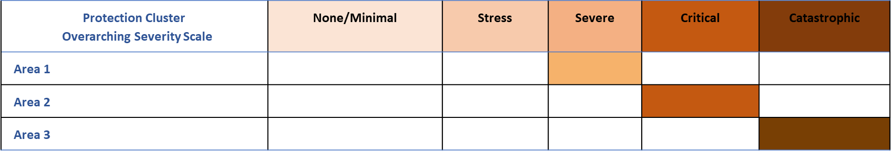
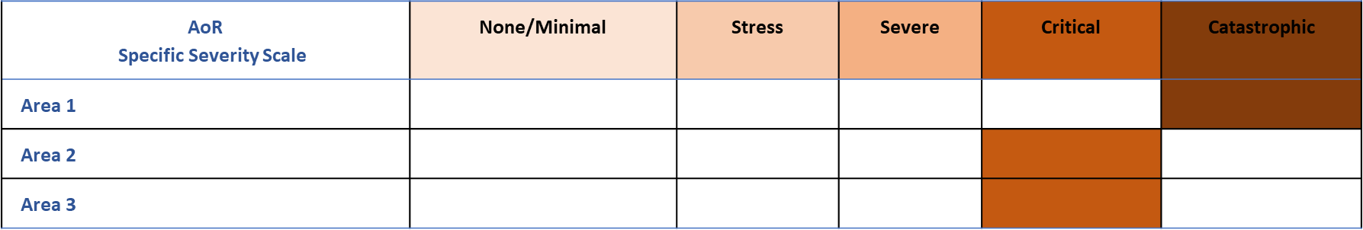
The ‘Analysis Team’ should facilitate the consensus process by bringing together sector coordinators and local experts. Analysis and interpretation of the consolidated information should be done one by one for each of the geographical units of analysis. Once agreement is reached, the discussion can move to the next area.

Next steps
Once the data consolidation and scoring phase is completed, the next steps will be:
- People in Need estimation (See HPC Guidance module 3 and note on ‘Global Protection Cluster PiN Estimation Method’)
- Expert workshops for joint analysis and interpretation (HPC Guidance module 4)

Examples

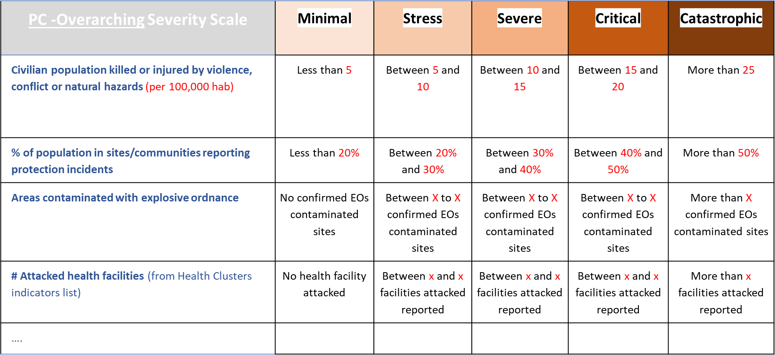
Protection overarching Severity Scale

AoR specific Severity Scale
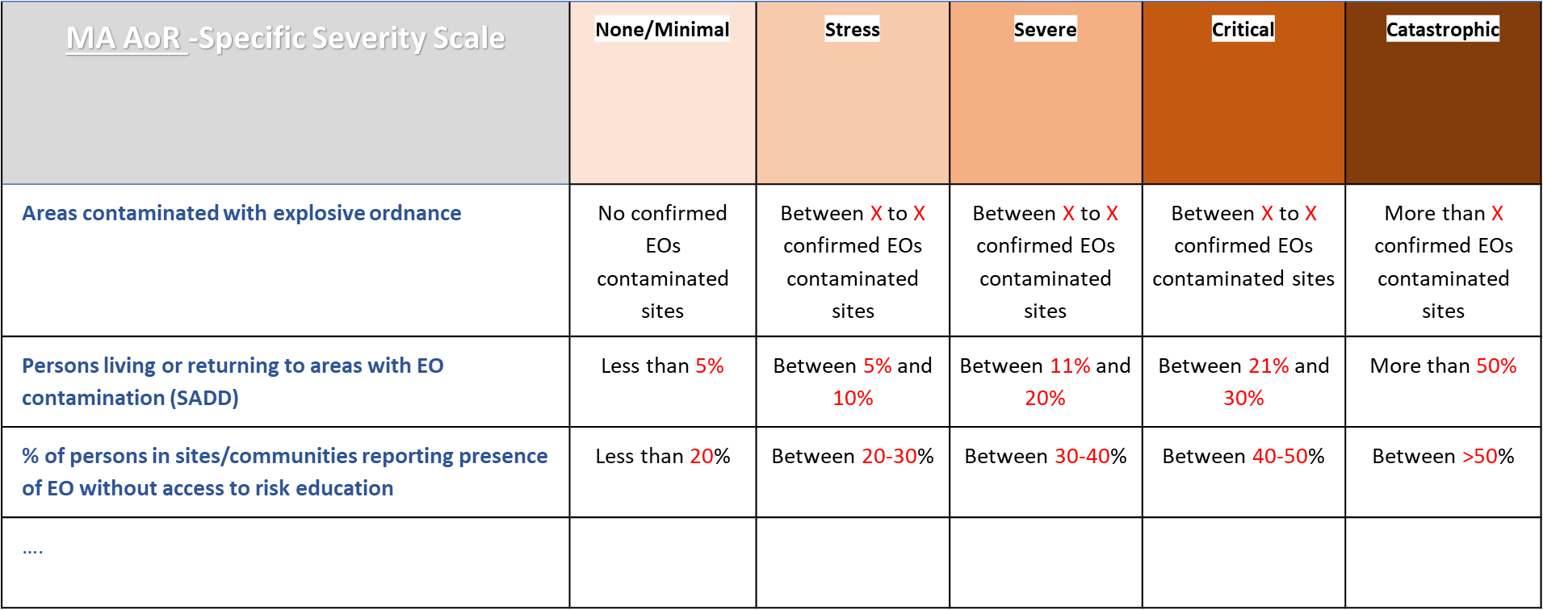

Designing own indicators and thresholds
If the team is unable to find indicators best suited to illustrate humanitarian needs in their country, it is possible to design own indicators based on the following core principles:
- Validity: select the indicator that provide a strong indication of humanitarian needs.
- Unit of Analysis: Regardless of the unit of analysis (household, area etc.), all results must be aggregated at the level (geographical area and/or affected group level) at which there is enough representative data to ensure confidence in the findings.
- Transparency: each indicator has a robust methodology attached to it.
- Severity thresholds: indicator must have severity thresholds organized along a five-point scale or at a minimum at three-point severity scale. The severity scale should be aligned with JIAF severity phase definitions. Severity scale 1 equals to ‘being not affected’, severity scale 2 equals to ‘being affected but not in need’, and severity scale 3 to 5 implies increasing level of needs.
- Disaggregation: data should be disaggregated by sex age and disability, where possible.
- Documentation: all the indicators should be documented and communicated to global cluster IMO for their information and improvement purposes. Once the indicator is reviewed and contextualized, the next step is to obtain data for the indicator.

Support request
If you encounter any challenge or difficulty during the process, please get in touch at:
Region | HPC Regional Coordination Focal Point | HPC Regional IM Focal Point
Asia/Pacific/Europe | David Winiger, winiger@unhcr.org | Kashif Rehman, rehmanka@unhcr.org
East & Southern Africa | Jessica Gorham, gorham@unfpa.org | Kashif Rehman, rehmanka@unhcr.org
Latin & Central America | Boris Aristin, aristing@unhcr.org | Boris Aristin, aristing@unhcr.org
MENA | Yasmine Elbehiery, elbehier@unhcr.org | Kashif Rehman, rehmanka@unhcr.org
West & Central Africa | Noemi Dalmonte, dozin@unhcr.org | Boris Aristin, aristing@unhcr.org

