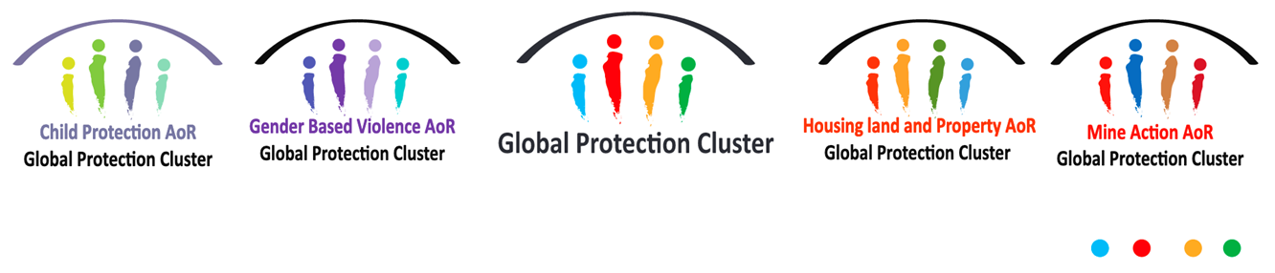

Dear Colleagues,

I hope that this message finds you well.

This is to invite you to a **Briefing on the Situation in [Country].**

**Date:** Thursday 16 September

**Time:** 14:00 to 15:00 pm (Geneva time) / XX:00 to XX:00 pm (Country time)

This meeting will be an opportunity to hear directly from [Name], [Title] in [Country] and discuss with our field Coordinators critical protection concerns, humanitarian access and progress on scaling up protection response in [Country] and beyond.

Please forward the invite and the agenda attached to relevant colleagues in your teams and kindly confirm your attendance to Celine Maret: [maret@unhcr.org](mailto:maret@unhcr.org).

We hope you will join us and look forward to your participation.

Best regards,

Celine Maret